Chapter 18, Solution 2.

Using Fig. 18.27, design a problem to help other students to better understand the Fouier transform given a wave shape.

Although there are many ways to solve this problem, this is an example based on the same kind of problem asked in the third edition.

Problem

What is the Fourier transform of the triangular pulse in Fig. 18.27?

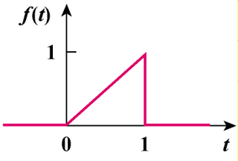

Figure 18.27

Solution

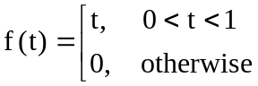
t
f ‘(t)
1
0
-δ(t-1)
1
t
f ”(t)
δ(t)
-δ(t-1)
–δ’(t-1)

f"(t) = δ(t) - δ(t - 1) - δ'(t - 1)

Taking the Fourier transform gives

-ω²F(ω) = 1 - e^{-jω} - jωe^{-jω}

F(ω) = 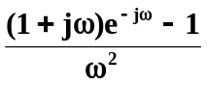

or 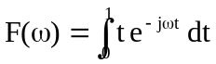

But 